Top ten most vaccinated locations in the world (by amount of people fully vaccinated)

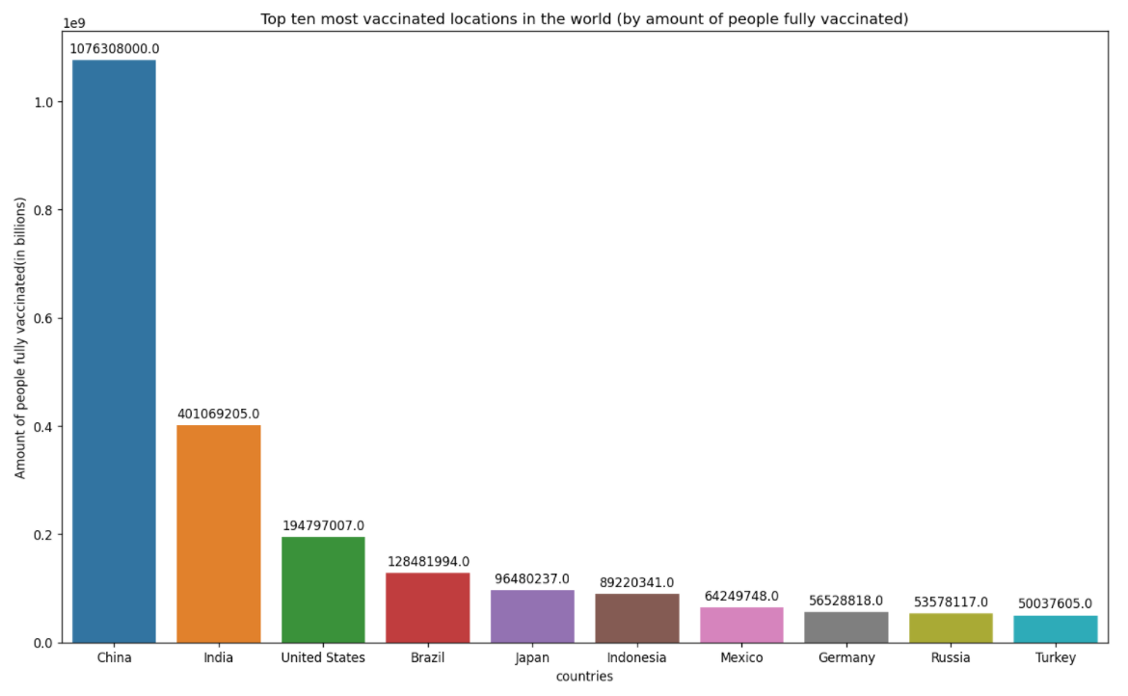 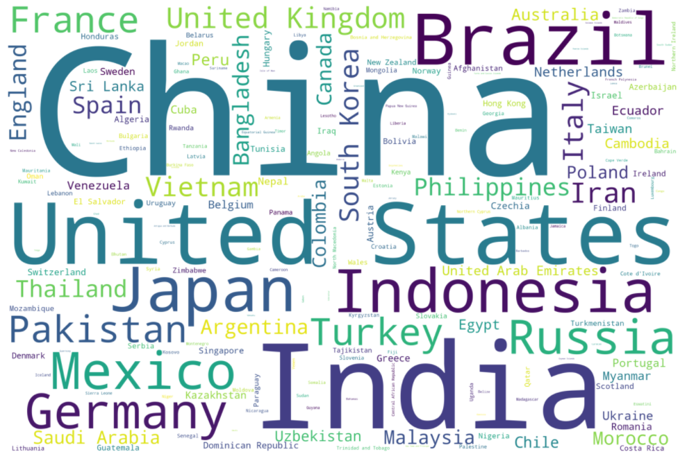

The graph on the left shows the top ten most vaccinated locations in the world sorted by the amount of people fully vaccinated.

The associated word cloud reflects the number of people fully vaccinated on the size of the text/country name. The bigger the size, the larger the number.

The word cloud also contains information about countries other than the top ten countries(all countries in the dataset).

But many of the top countries are also the most populous, we have to take into account the fully vaccinated rate.

In this case, the fully vaccinated rate(per hundred) matters when analyzing vaccination trends and the possible new variants emerged.

Top ten locations that people actively participate in getting vaccination (by amount of people vaccinated daily)

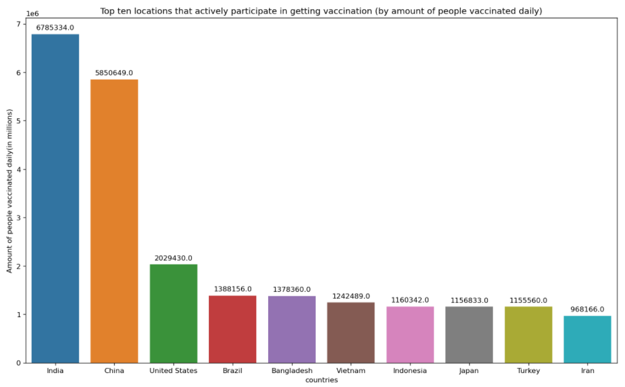 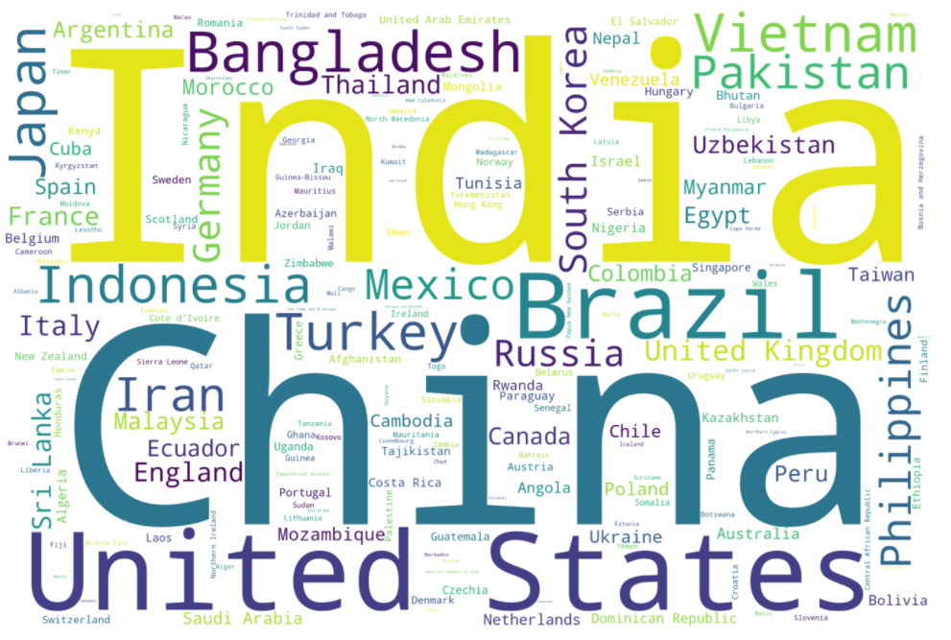

The graph on the left shows the top ten locations that people actively participate in getting vaccination sorted by the amount of people vaccinated daily.

The associated word cloud reflects the number of people vaccinated daily on the size of the text/country name. The bigger the size, the larger the number.

The word cloud also contains information about countries other than the top ten countries(all countries in the dataset).

We can also see a pattern here. Most of the top countries can produce vaccines themselves such as the US and China. The countries with larger vaccine supply, bigger populations and more resources seems to have people that are more active in getting vaccinations. So, the amount of people getting vaccinated daily does have something to do with the amount of daily produced vaccines as well.

MONTE CARLO simulation model results

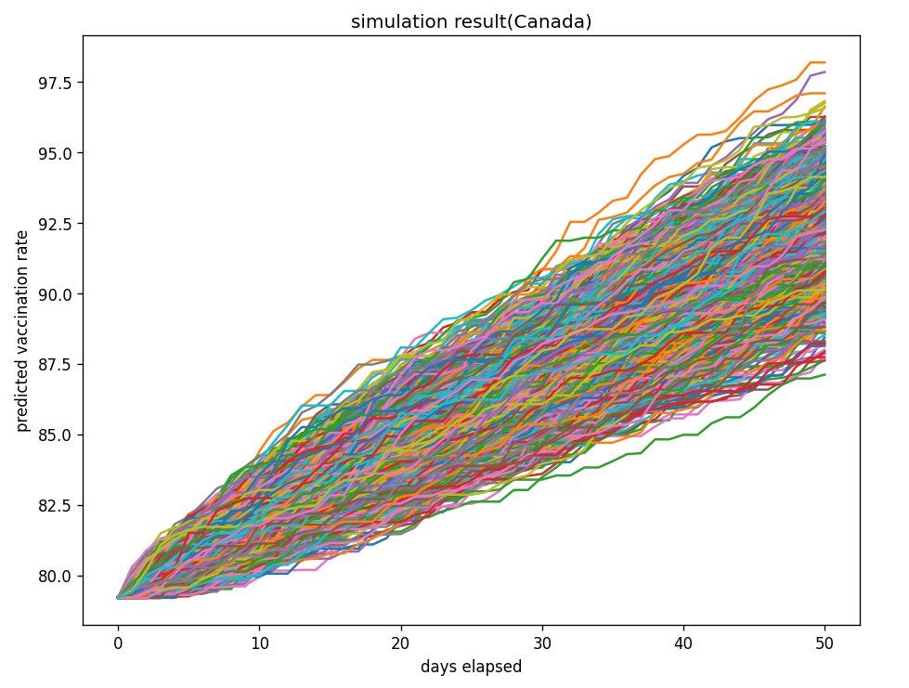 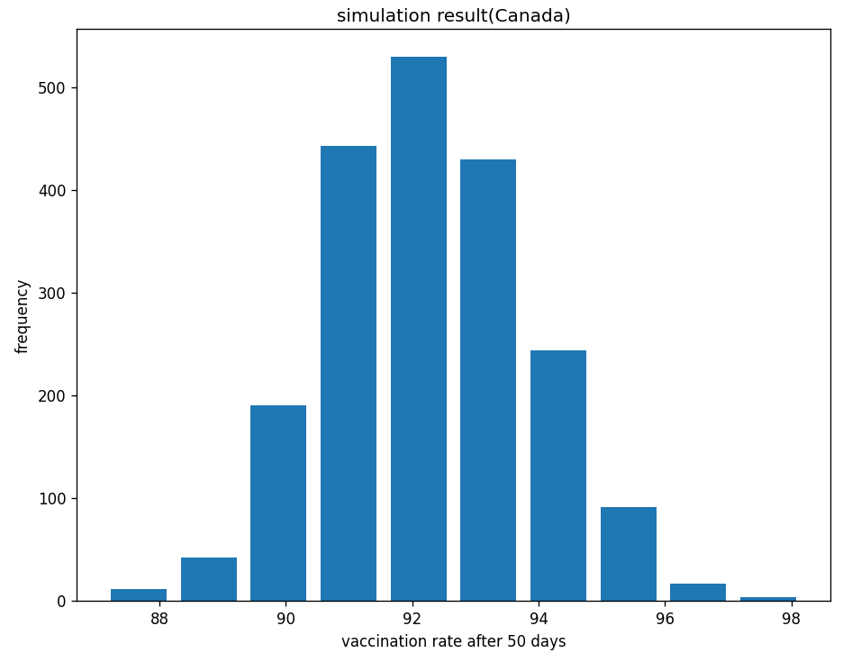

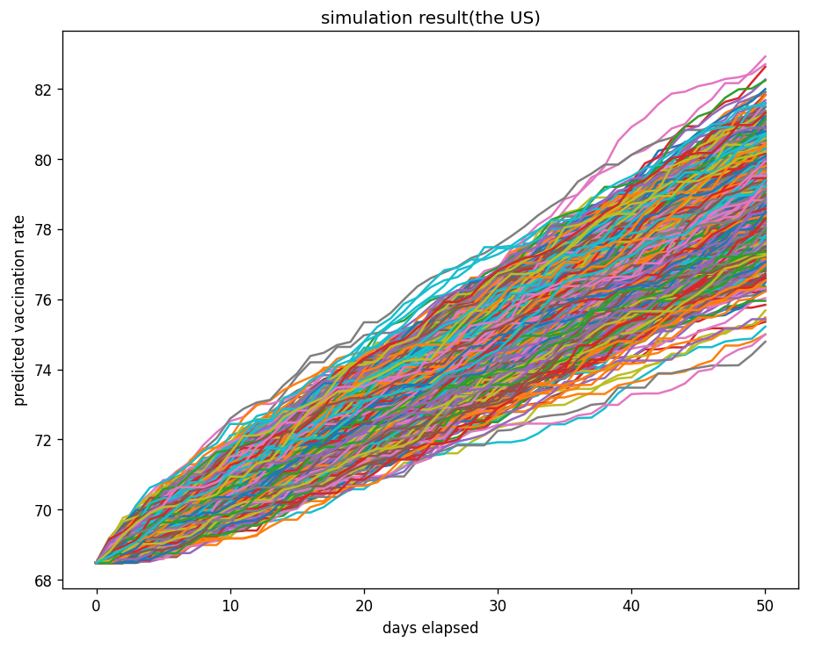 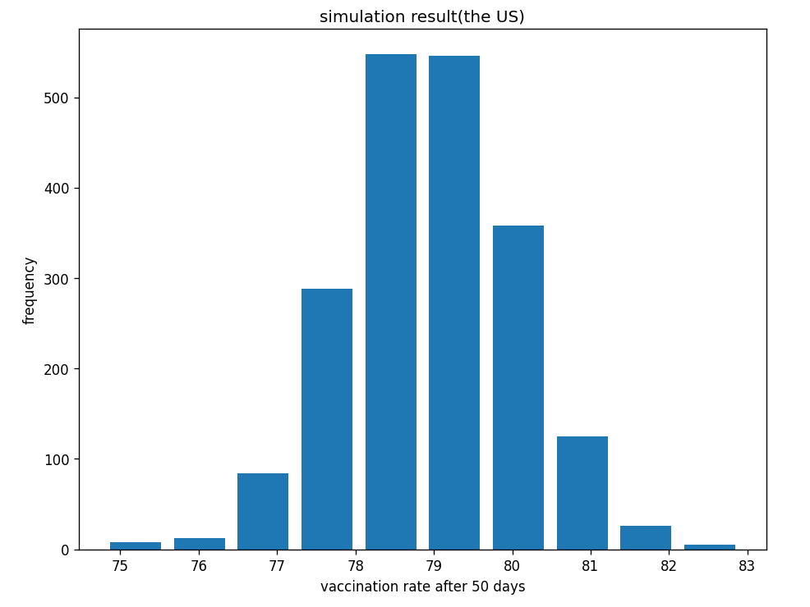

The top 2 graphs represent the Monte Carlo simulation result and distribution in the next 50 days for Canada and the bottom 2 are for the US.

We simulate 2000 times for each country and we use 99% confidence interval to get our best and worst cases for each country.

We can see that their distributions are very similar and follow a normal distribution.

It is because we create random variables based on past data’s mean and standard deviation. These random variables generated should follow normal distribution. Since we simulated relatively large enough times(2000 times), The result should resemble a normal distribution as well.

ARIMA model results(left:Canada, right: the US)

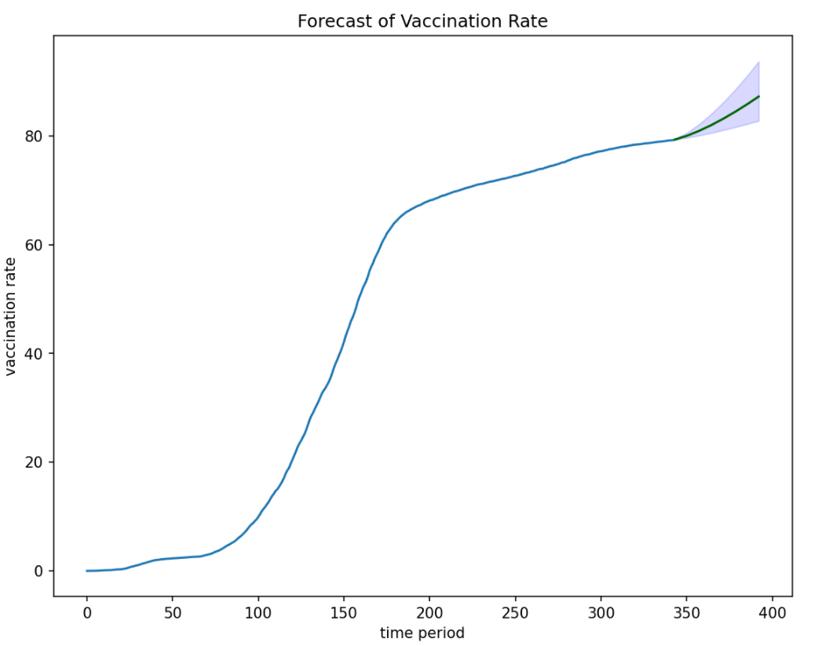 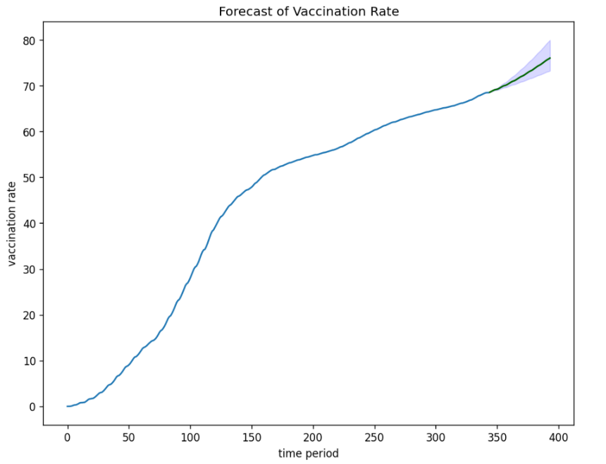

Canada and the US have very similar curves for vaccination rate. Their vaccination rates first increase very fast to a certain limit(time period 150-200) and they start to increase with lower rate. But there is a big difference despite they have similar vaccination curves. Canada's vaccination rate has a very fast rate of increase until around 70% vaccination rate and then the rate of increase started to fall. But for the US, it is 50%. This means although they all have high rate of increase at the middle, Canada's rate(period 100-200) is greater and it nearly approaches exponential. So the Arima model predicts a larger increase in vaccination rate for Canada then for the US.(8.02% for Canada and 7.55% for the US)

combination of the results

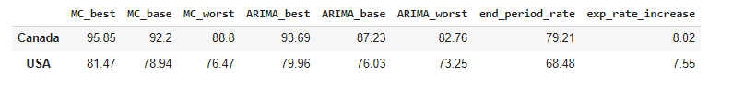

If we only take the increase in the number of people who will get vaccinated in the next 50 days as the benchmark for deciding which country has a better vaccination program, then obviously the US has a better vaccination program. But it is not a good measure because the population in the US is nearly ten times the population in Canada. In other words, it is not a fair comparison. In this case, the increase in vaccination rate maybe a better measure. We can compare the efficiency of the vaccination program from the following 5 aspects. First, if we only use past data, we can see that the vaccination rate for Canada on the last day in the dataset is 79.21% and it is 68.48% for the US. Second, if we use our time series model(Arima in this case) to predict the increase in the vaccination rate in the next 50 days, Canada has an expected increase in vaccination rate of 8.02% and for the US it is 7.55%. Third, if we combine the the previous two rates together, we see that the expected vaccination rate at the end of the next fifty days for Canada is 87.23% and for US it is 76.03%. Fourth, the fully vaccination rate for Canada on the last day in the dataset is 75.79%, while for the US, it is 57.92%. The last aspect considers the shape of vaccination rate curve we explored in part3. As mentioned before, Canada and the US have very similar shape of curves but Canada has a higher rate of increase in vaccination rate before period 200. After that , the 2 countries have comparable rate of increase.

We can see that the time periods given in the past data for the 2 countries are nearly the same(12/14/2020-11/21/2021). If we analyze using the 5 aspects mentioned above, we find that Canada always have a greater (expected) vaccination rate or expected rate of increase than the US. We may conclude that Canada has a better vaccination program based on our analysis.